**OVERVIEW OF THE SYSTEM – PERFORMANCE MANAGEMENT**

1. **Performance Management dashboard**

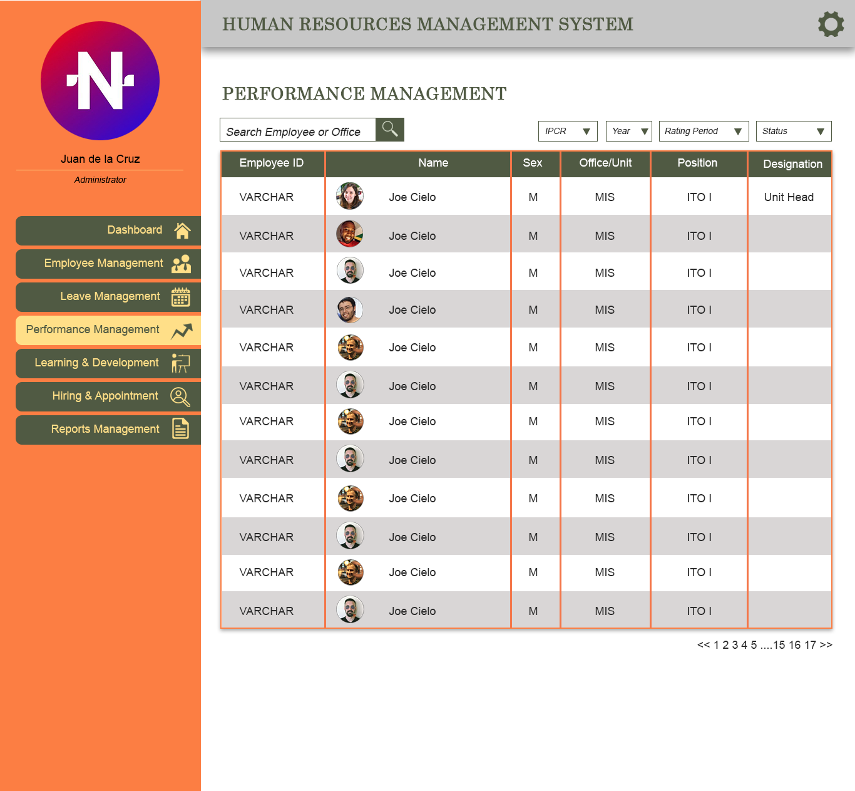

An employee submits performance rating twice a year. The **rating periods** are: 1. January – June, 2. July – December.

There are 2 **types** of performance rating; for a regular employee, he/she will submit IPCR (INDIVIDUAL PERFORMANCE COMMITMENT AND REVIEW). For an Office or department head or supervisor, he/she will submit DPCR (DIVISION PERFORMANCE COMMITMENT AND REVIEW).

The performance ratings are important for employees to submit for them to be qualified for some benefits like bonuses and others. This is why the Admin always needs to monitor the **status** (Submitted, not Submitted) of the employees if they submitted their performance ratings at the end of each rating period.

**ADMIN FUNCTIONS**

* The Admin can search employee or office in the search field.
* The Admin can also filter the list with Type of rating (IPCR, DPCR), Year of rating, Rating Period (January to June, July to December), and status (Submitted, No Submission)
* Once the Admin clicks on a certain employee in the list, it will show a modal containing the employee performance rating submissions.

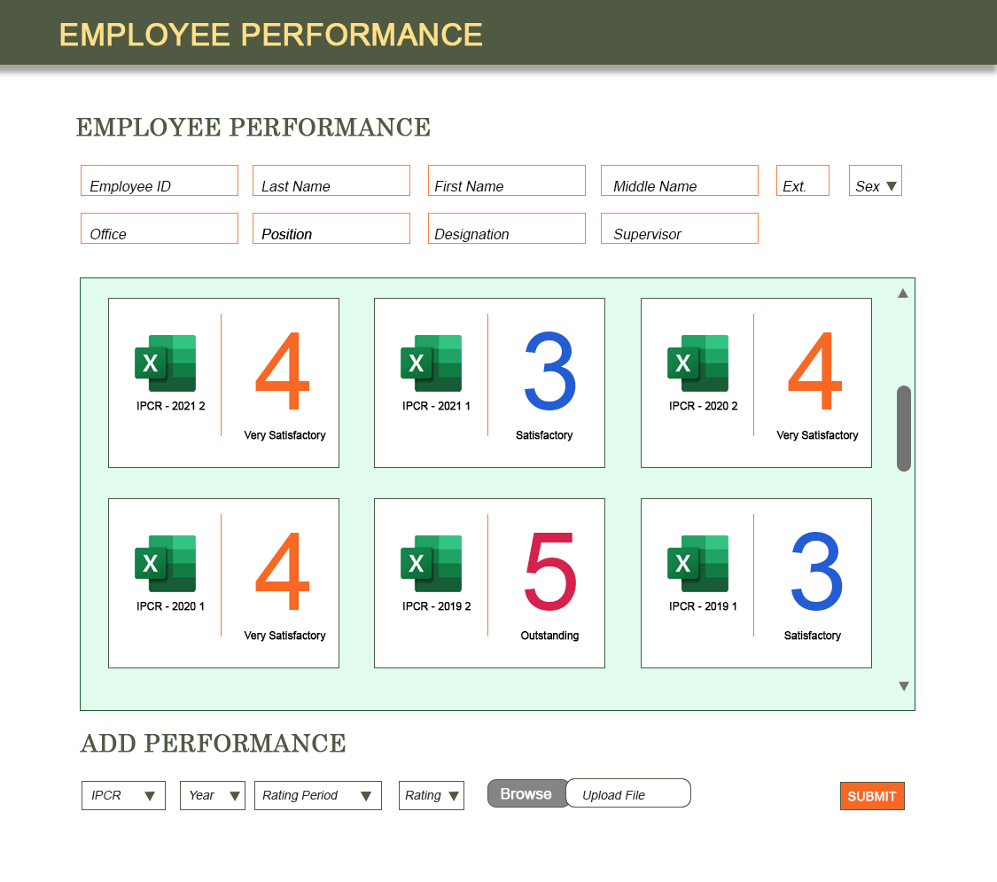

* The cards in the container consists of the submissions where the details are indicated. Example: Card 1 consists of the Type = IPCR, Year = 2021, Rating period = 2 or the July to December period. It also shows the Final rating of the employee with its corresponding value. 4 = Very Satisfactory.
* These performance ratings are added and uploaded by the employees using their user accounts (No prototype yet for user or employees’ account).
* The Admin can also ADD employees performance in this modal and once SUBMIT button is clicked, it will update and add a card containing the latest update.

The excel files are samples of IPCR and DPCR forms. These forms are the files being uploaded by both employee and admin.